**ABSTRACT**

The project, StarGateway Hotel Reservation System is a web based application that allows the Hotel Admin to handle hotel reservation activities online. Project provides room booking and other necessary hotel reservation features. The system allows the Admin to manage rooms, services, categories in the system. Customers can view available rooms and book room online. Other hotel services can also be viewed by the customers.

**INDEX**

|  |  |  |
| --- | --- | --- |
|  | **INDEX** |  |
|  | **LIST OF TABLES** |  |
|  | **LIST OF FIGURES** |  |
| **1.** | **INTRODUCTION** | 5 |
| **2.** | **PRODUCT OVERVIEW AND SUMMARY** | 6 |
|  | 2.1 Scope | 6 |
|  | 2.2 Design and Implementation Constraints | 7 |
| **3.** | **REQUIREMENTS** | 8 |
|  | 3.1 Functional Requirements | 8 |
|  | 3.1.1 Use case for Administrator. | 9 |
|  | 3.1.2 Use case for Customer. | 10 |
| **4.** | **PROJECT DESIGN** | 11 |
|  | 4.1 Data Model | 11 |
|  | 4.1.1 Database Design | 11 |
|  | 4.2 Process Model | 16 |
|  | 4.2.1 Data Flow Diagram (DFD) | 18 |
| **5.** | **PROJECT RELATED STATISTICS** | 19 |

**LIST OF TABLES**

|  |  |  |
| --- | --- | --- |
| **Section** | **Table Title** | **Page** |
| **4.1.1** | **User** | 11 |
| **4.1.1** | **Booking** | 12 |
| **4.1.1** | **Rooms** | 12 |
| **4.1.1** | **Facility** | 13 |
| **4.1.1** | **Room Category** | 13 |
| **4.1.1** | **Room Facility** | 14 |
| **4.1.1** | **Enquiry** | 14 |
| **4.1.1** | **Idproof** | 14 |
| **4.1.1** | **Offers** | 15 |
| **4.1.1** | **Contact Us** | 15 |

**LIST OF FIGURES**

|  |  |  |
| --- | --- | --- |
| **Section** | **Figure Title** | **Page** |
| **2.0** | **Enhanced Entity-Relationship Diagram** | **7** |
| **3.0** | **Common Functionalities** | **8** |
| **3.1** | **Admin** | **9** |
| **3.2** | **User** | **10** |
| **4.2** | **Data Flow Diagram** | **18** |
| **5.0** | **Home Page** | **19** |
|  | **Sign Up** | **19** |
|  | **Sign In** | **20** |
|  | **Sign In Toast Success** | **20** |
|  | **Sign In Toast Error** | **20** |
|  | **Edit Profile** | **21** |
|  | **Change Password** | **21** |
|  | **Rooms** | **21** |
|  | **Facility** | **22** |
|  | **Offers** | **22** |
|  | **My Booking** | **22** |
|  | **Available Rooms** | **23** |
|  | **Book Room** | **23** |
|  | **Contact Us** | **23** |
|  | **Enquiry** | **24** |
|  | **Admin Home** | **24** |
|  | **Add Room** | **24** |
|  | **Room List** | **25** |
|  | **User List** | **25** |
|  | **Booking List** | **25** |
|  | **Add Idproof** | **26** |
|  | **Idproof List** | **26** |
|  | **Add Room Category** | **26** |
|  | **Room Category List** | **27** |
|  | **Add Facility** | **27** |
|  | **Facility List** | **27** |
|  | **Enquiry List** | **28** |
|  | **Add Offers** | **28** |
|  | **Offers List** | **28** |
|  | **Search By User Id** | **29** |
|  | **Search By Booking Id** | **29** |
|  | **Search By Dates** | **29** |
|  | **Edit Contact Us** | **30** |

* **INTRODUCTION**

Now a days people goes to different places for relaxation or recreation. As, there are not so many available hotels & Resorts for large number of people. In a vacation, most of the peoples will go different tourist places for relaxation or recreation and faced problematic situation if there unavailability of room in Hotel or Resort. It will be overcome if the hotels has online booking system.

So we thought that if the Hotel has online room booking and availability checking system, we can provide the system to customers through Online, then it will be convenient and helpful for a customer perspective to Book/Reserve a Room or checking the price, availability and other facilities.

With that inspiration we created a web application “**StarGateway Hotel Reservation System**” to help the People who are basically like to confirm the booking before the traveling to minimize the hassle during the traveling. Moreover, Management also gets a view about the Daily/Monthly data of tourist and also able to compare with the costing to find out the Net Income.

* **PRODUCT OVERVIEW AND SUMMARY**

**SCOPE:**

* The project, StarGateway Hotel Reservation System is a web-based application that allows the resort Admin to handle all hotel reservation activities online.
* Project provides room booking and other necessary hotel reservation features.
* The system allows the admin to post available rooms, facility, offers in the

system.

* Customers can view and book rooms online & customers can send Enquiry.
* Other hotel services can also be viewed by the customer.
* **Design and Implementation Constraints**

**Enhanced Entity-Relationship Diagram**

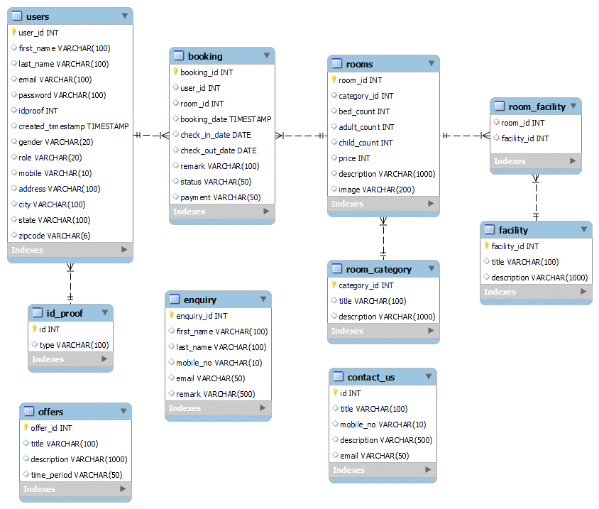

EER Diagram

**REQUIREMENTS**

**3.1 Functional Requirements**

**USECASE Diagram:**

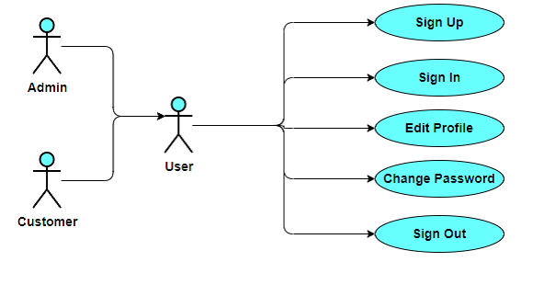

**Common Functionalities**

This usecase diagram describe the common functionalities between the both the user customer and the admin.

* Admin can login, logout and can view the booking, enquiry .etc.
* customer can also login, logout and can able to see booking details.

**3.1.1 Use Case of Administration Requirement**

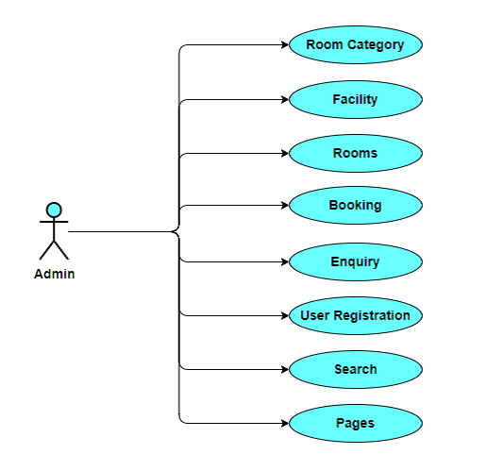

**Admin**

* This diagram describes the role of an admin.
* Room category – admin can add/edit/delete room category.
* Facility – admin can add/edit/delete facilities to be provided.
* Rooms – admin can add/edit/delete rooms under room category with specific facilities.
* Booking – admin can view the booking request and can take appropriate action.
* Enquiry – admin can view the enquiry send by customers.
* User registration – admin can add new customer/admin.
* Search – admin can search booking/enquiry by id or between specific date intervals.
* Pages – admin can Edit the details on Contact us pages.
* Offers- admin can Add Offers for certain period of Time.
* **Use Case of User**

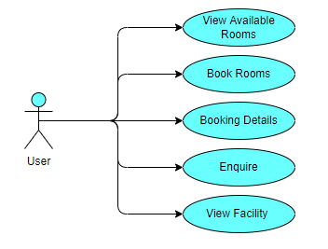

* View Rooms – customer can view rooms under various categories.
* Book Available Room – customer can book room for specific days.
* Booking Details – customer can view his booking details and status of booking, booking history.
* Enquiry – customer can send enquiry with message.
* View Offers – customer can view offers and its description posted.
* **Project Design**

**4.1.1 Database Design**

**User**

|  |  |  |  |  |  |
| --- | --- | --- | --- | --- | --- |
| **Field** | **Type** | **Null** | **Key** | **Default** | **Extra** |
| user_id | int(11) | NO | PRI | NULL | Auto increment |
| first_name | varchar(100) | YES |  | NULL |  |
| last_name | varchar(100) | YES |  | NULL |  |
| email | varchar(100) | YES | UNI | NULL |  |
| password | varchar(100) | YES |  | NULL |  |
| idproof | int(11) | YES | MUL | 1 |  |
| created_timestamp | timestamp | YES |  | CURRENT_TIMESTAMP |  |
| gender | varchar(20) | YES |  | NULL |  |
| role | varchar(20) | YES |  | NULL |  |
| mobile | varchar(10) | YES |  | NULL |  |
| address | varchar(100) | YES |  | NULL |  |
| city | varchar(100) | YES |  | NULL |  |
| state | varchar(100) | YES |  | NULL |  |
| zipcode | varchar(06) | YES |  | NULL |  |

**Booking**

Table:booking

Description:It is having booking details.

|  |  |  |  |  |  |
| --- | --- | --- | --- | --- | --- |
| **Field** | **Type** | **Null** | **Key** | **Default** | **Extra** |
| booking_id | int(11) | NO | PRI | NULL | Auto increment |
| user_id | int(11) | YES | MUL | NULL |  |
| room_id | int(11) | YES | MUL | NULL |  |
| booking_date | timestamp | YES |  | CURRENT_TIMESTAMP |  |
| check_in_date | date | YES |  | NULL |  |
| check_out_date | date | YES |  | NULL |  |
| remark | varchar(100) | YES |  | NULL |  |
| status | varchar(50) | YES |  | Pending |  |
| payment | varchar(50) | YES |  | Pending |  |

**Rooms**

|  |  |  |  |  |  |
| --- | --- | --- | --- | --- | --- |
| **Field** | **Type** | **Null** | **Key** | **Default** | **Extra** |
| room_id | int(11) | NO | PRI | NULL | Auto increment |
| category_id | int(11) | YES | MUL | 1 |  |
| adult_count | int(11) | YES |  | NULL |  |
| child_count | int(11) | YES |  | NULL |  |
| price | int(11) | YES |  | NULL |  |
| description | varchar(1000) | YES |  | NULL |  |
| image | varchar(200) | YES |  | NULL |  |

**Facility**

Table: facility

Description: This Table will maintain facility details.

|  |  |  |  |  |  |
| --- | --- | --- | --- | --- | --- |
| **Field** | **Type** | **Null** | **Key** | **Default** | **Extra** |
| facility_id | int(11) | NO | PRI | NULL | Auto increment |
| Title | int(11) | YES |  | NULL |  |
| description | int(11) | YES |  | NULL |  |

**Category**

Table: room_category

Description: It contains List of room_category

|  |  |  |  |  |  |
| --- | --- | --- | --- | --- | --- |
| **Field** | **Type** | **Null** | **Key** | **Default** | **Extra** |
| facility_id | int(11) | NO | PRI | NULL | Auto increment |
| Title | int(11) | YES |  | NULL |  |
| description | int(11) | YES |  | NULL |  |

**Room Facility**

Table: room_facility

Description: It contains List of room_facility

|  |  |  |  |  |  |
| --- | --- | --- | --- | --- | --- |
| **Field** | **Type** | **Null** | **Key** | **Default** | **Extra** |
| room_id | int(11) | YES | MUL | NULL |  |
| facility_id | int(11) | YES | MUL | NULL |  |

**Enquiry**

Table: enquiry

Description: It contains List of enquiry

|  |  |  |  |  |  |
| --- | --- | --- | --- | --- | --- |
| **Field** | **Type** | **Null** | **Key** | **Default** | **Extra** |
| enquiry_id | int(11) | NO | PRI | NULL | Auto increment |
| first_name | varchar(100) | YES |  | NULL |  |
| last_name | varchar(100) | YES |  | NULL |  |
| mobile_no | varchar(10) | YES |  | NULL |  |
| email | varchar(50) | YES |  | NULL |  |
| remark | varchar(500) | YES |  | NULL |  |

**Id Proof**

Table: id_proof

Description: It contains list of id proofs

|  |  |  |  |  |  |
| --- | --- | --- | --- | --- | --- |
| **Field** | **Type** | **Null** | **Key** | **Default** | **Extra** |
| Id | int(11) | NO | PRI | NULL | Auto increment |
| Type | varchar(100) | YES |  | NULL |  |

**Offers**

Table: offers

Description: It contains List of offers

|  |  |  |  |  |  |
| --- | --- | --- | --- | --- | --- |
| **Field** | **Type** | **Null** | **Key** | **Default** | **Extra** |
| offer_id | int(11) | NO | PRI | NULL | Auto increment |
| Title | varchar(100) | YES |  | NULL |  |
| description | varchar(1000) | YES |  | NULL |  |
| time_period | varchar(50) | YES |  | NULL |  |

**Contact Us**

Table: contact_us

Description: It contains contact us details

|  |  |  |  |  |  |
| --- | --- | --- | --- | --- | --- |
| **Field** | **Type** | **Null** | **Key** | **Default** | **Extra** |
| id | int | NO | PRI | NULL | Auto increment |
| title | varchar(100) | YES |  | NULL |  |
| Mobile_no | varchar(10) | NO |  | NULL |  |
| description | varchar(500) | YES |  | NULL |  |
| email | varchar(50) | NO |  | NULL |  |

* **Process Model**

A software process model is a standardized format for following stages of

software developing.

* Planning
* Organizing
* Running a development project.

variations on a small number of basic models. We surveyed the important basic models, and tried how to choose between

them. We have to consider following constraints while building a software or any real-world project.

A (software/system) process model is a description of the sequence of

activities carried out in a software project, and the relative order of these

activities.

A process model provides a fixed generic framework that can be tailored to a

specific project. Project specific parameters will include: Size, (person-years), Budget, Duration

Project Plan = Process Model + Project Parameters.

There are different types of basic process models are existed, in our project we used Agile model as a process model.

Agile modelling is a methodology for modelling and documenting software systems based on best practices. It is a collection of values and principles that can be applied on an (agile) software development project. This methodology is more flexible than traditional modelling methods, making it a better fit in a fast changing environment. It is part of the agile software development tool kit.

**4.2.1 Data Flow Diagram (DFD)**

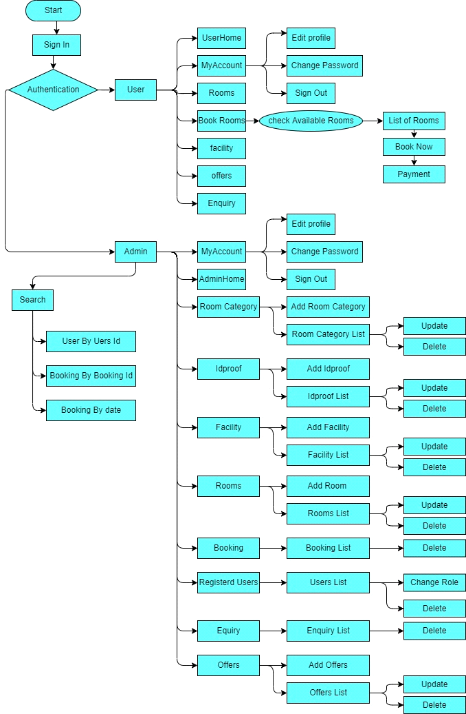

* **PROJECT RELATED STATISTICS**

­­­­Project related statistics shows what the realistic scenario of our project . It includes actual look and feel, functionality of the project. Following are some screenshots of our project that is Project management System.

**Home Page**

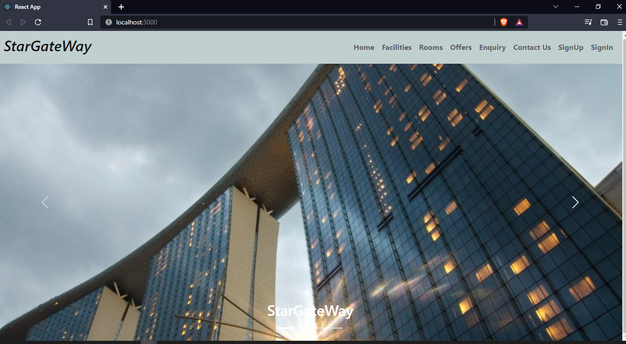

**Sign Up**

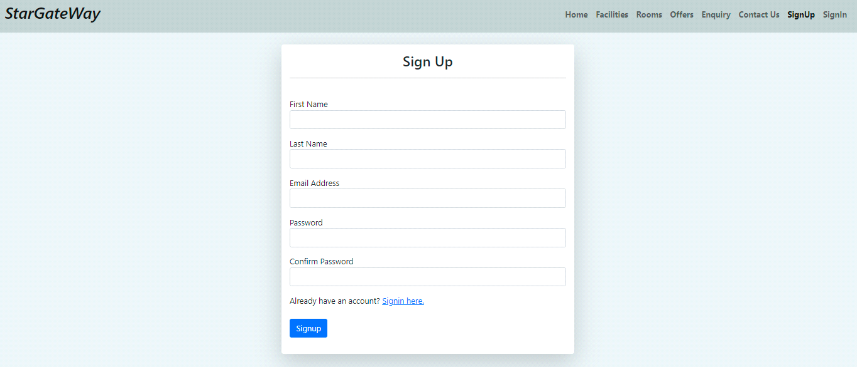

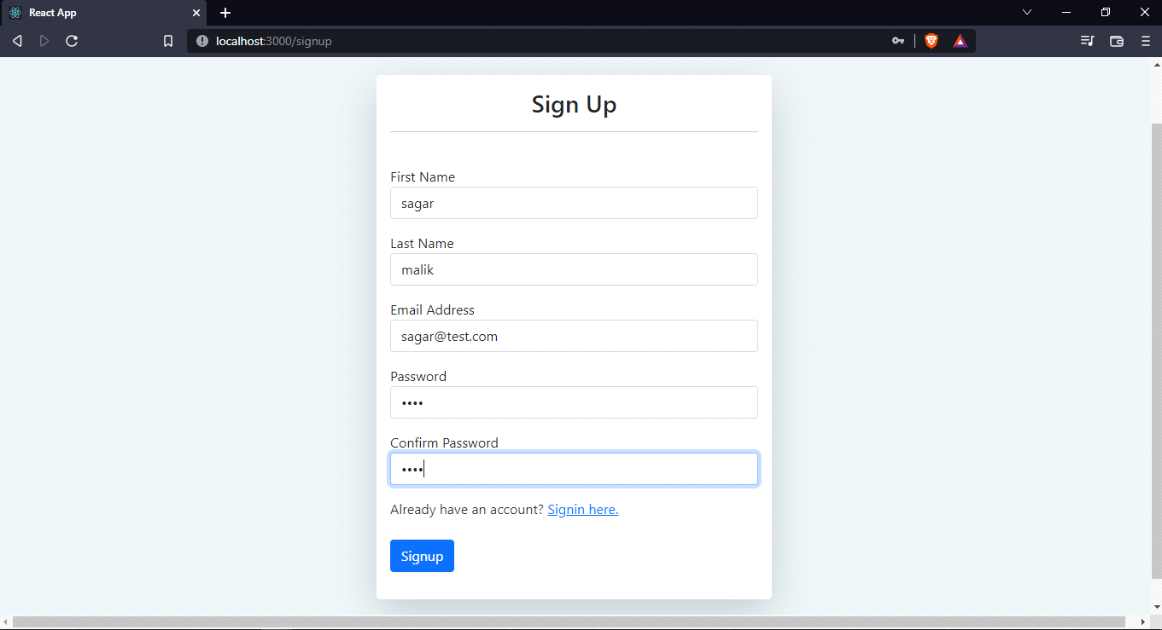

**Sign In**

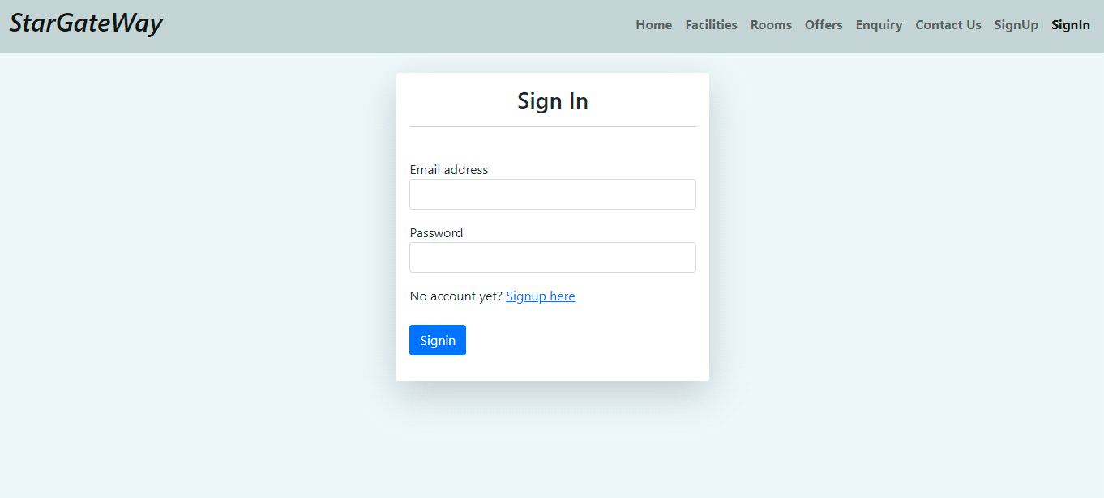

**Sign In Toast Success**

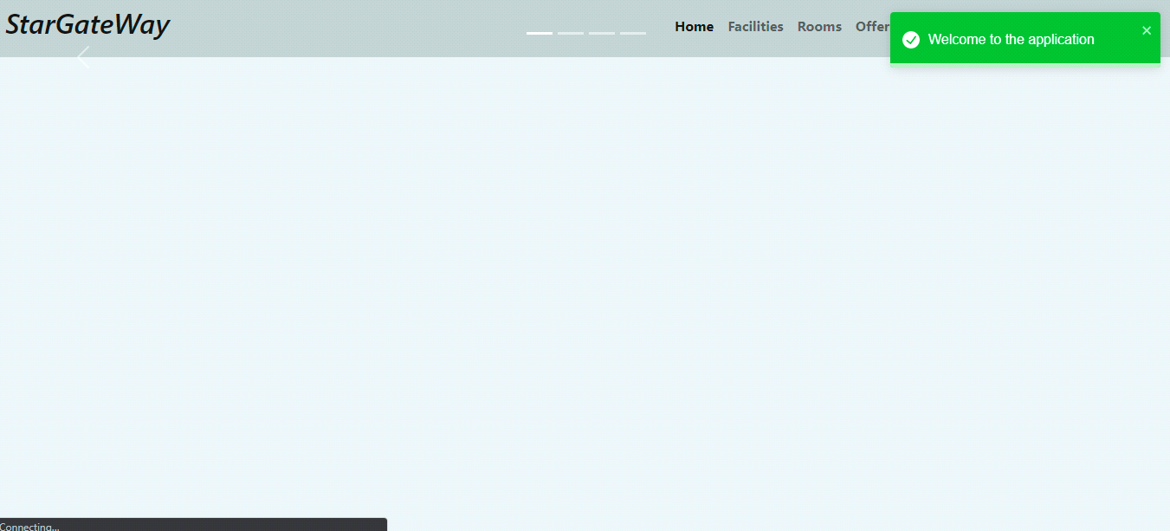

**Sign In Toast Error**

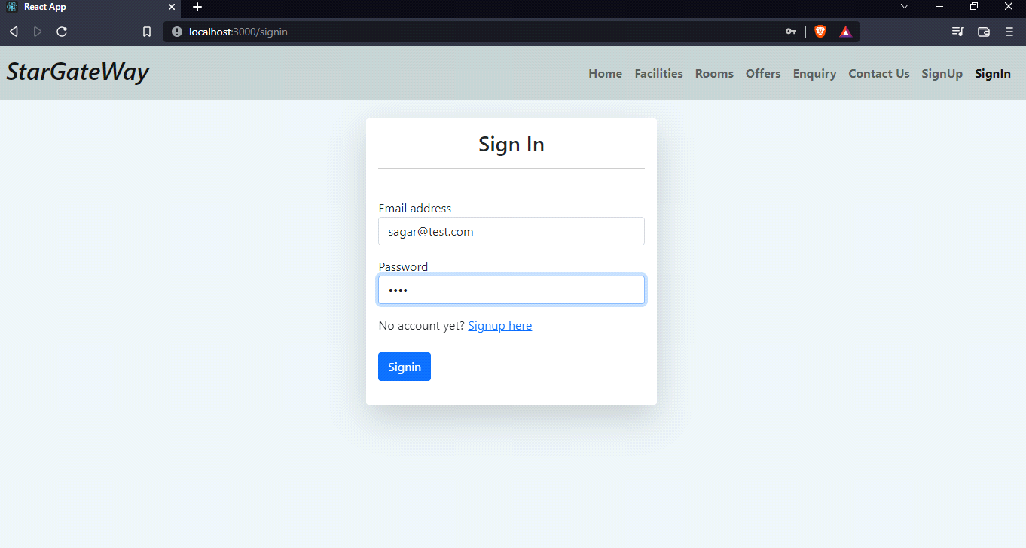

**Edit Profile**

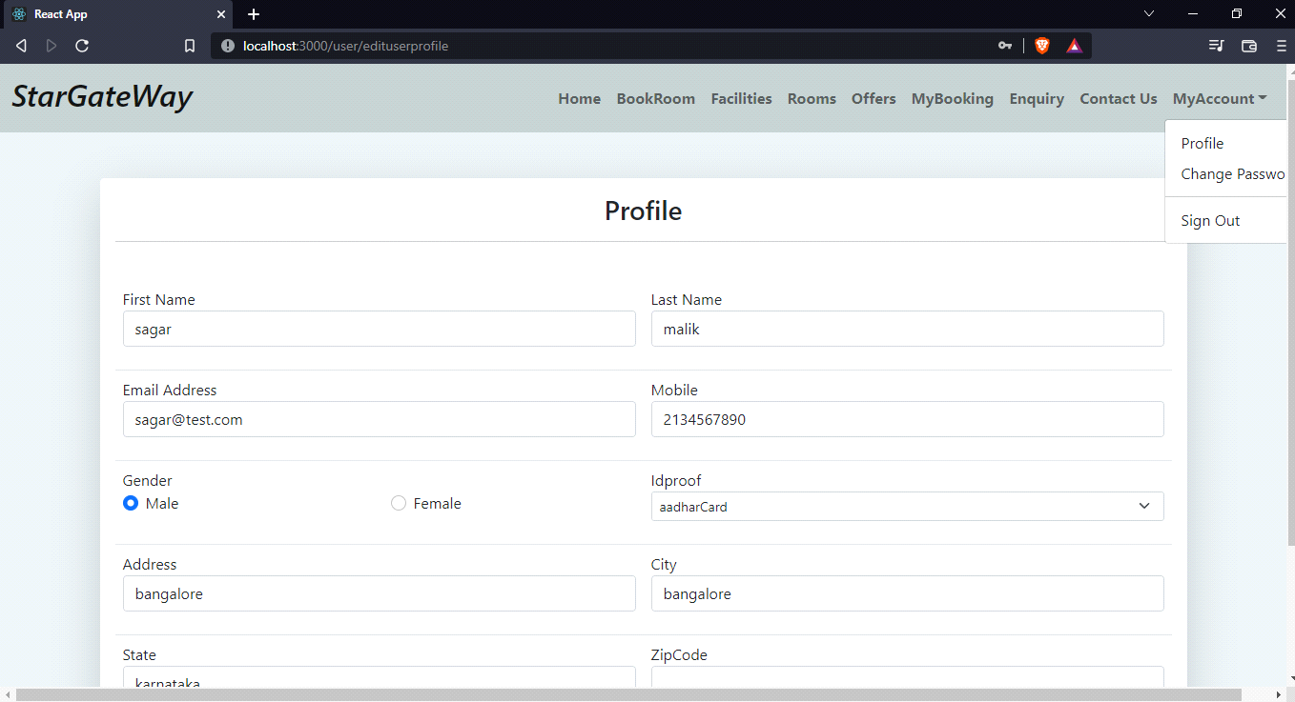

**Change Password**

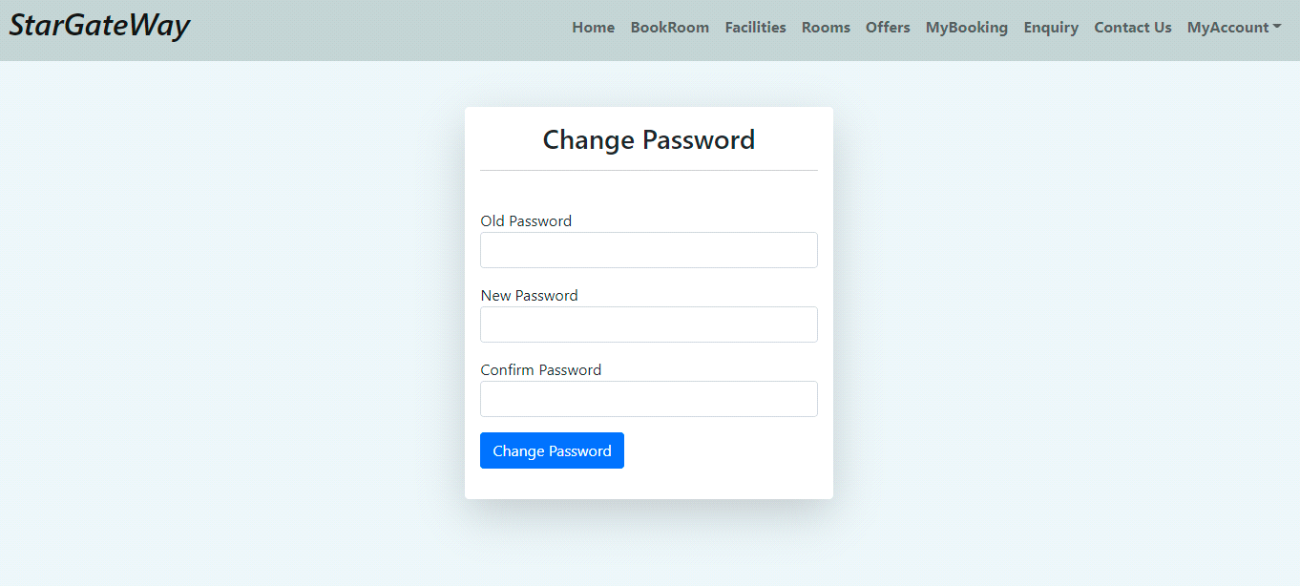

**Rooms**

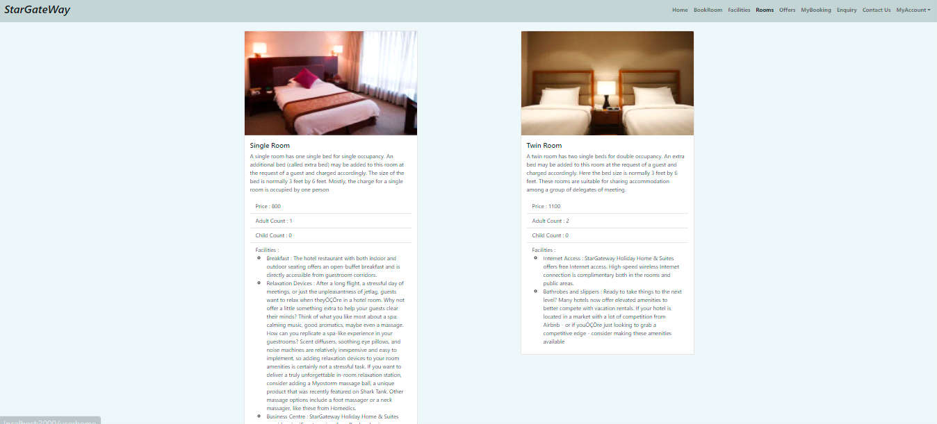

**Facility**

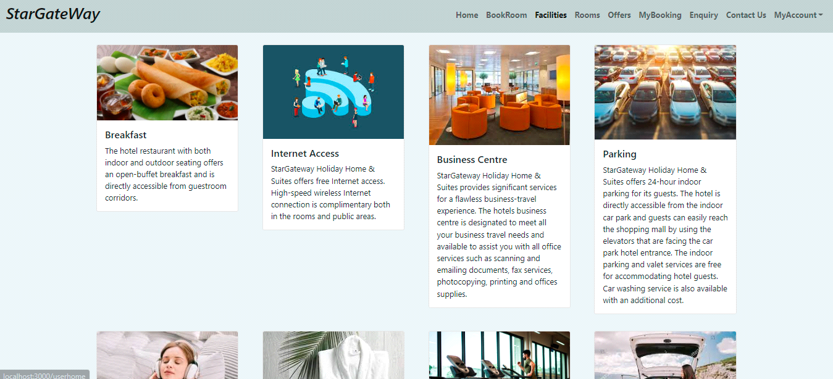

**Offers**

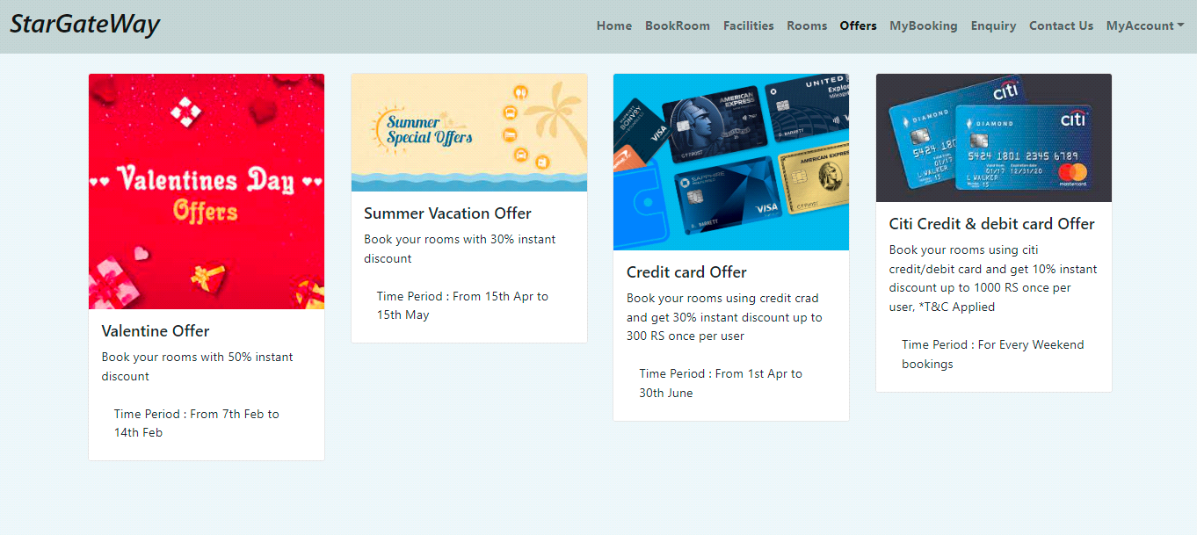

**My Booking**

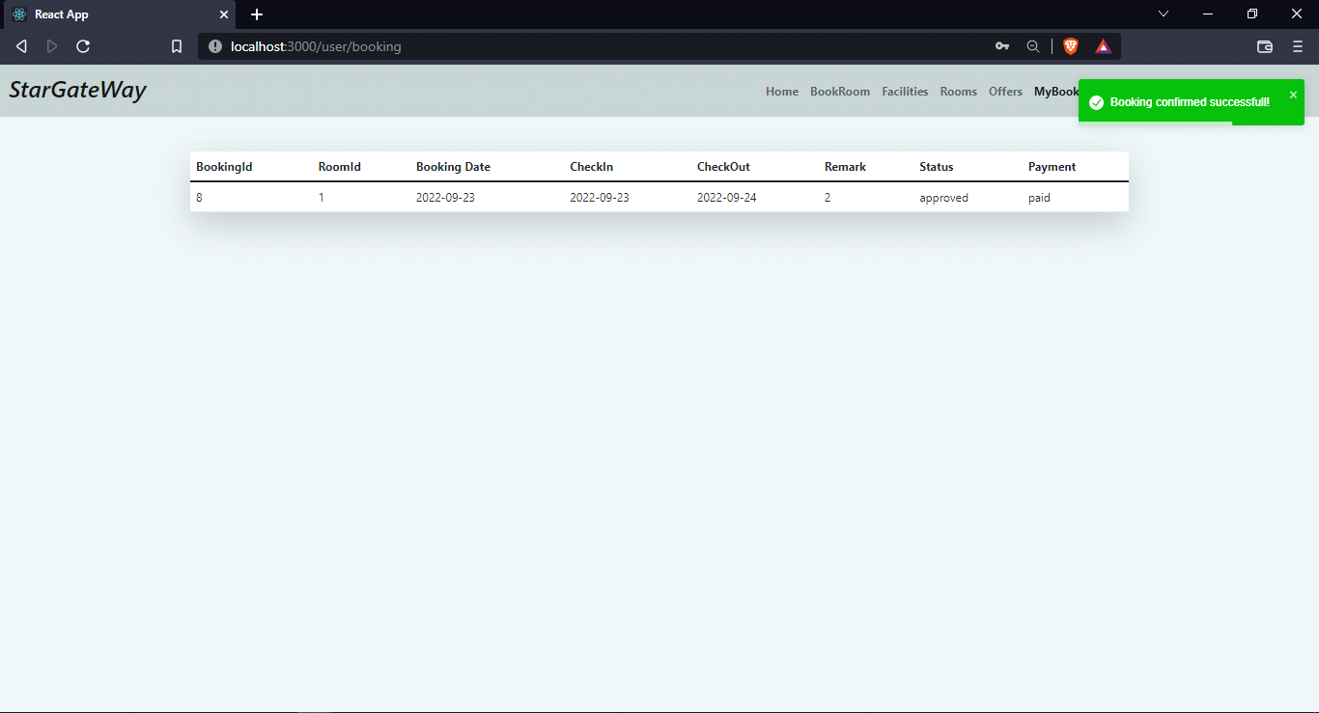

**Available Room**

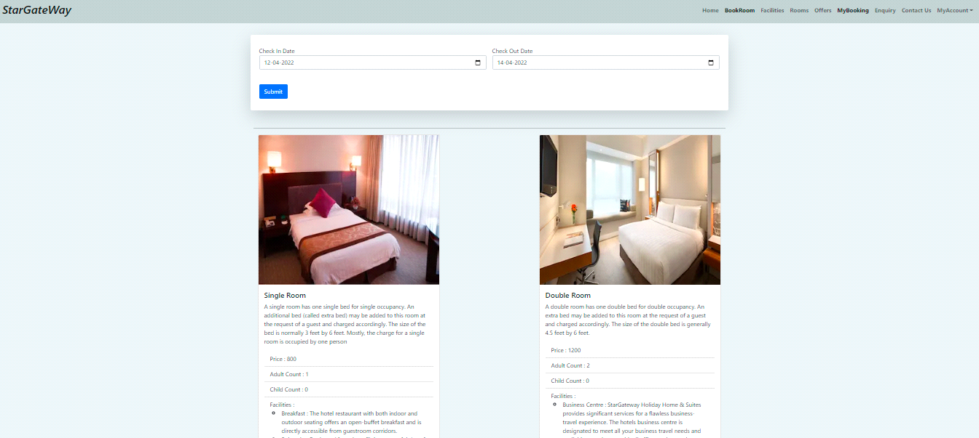

**Book Room**

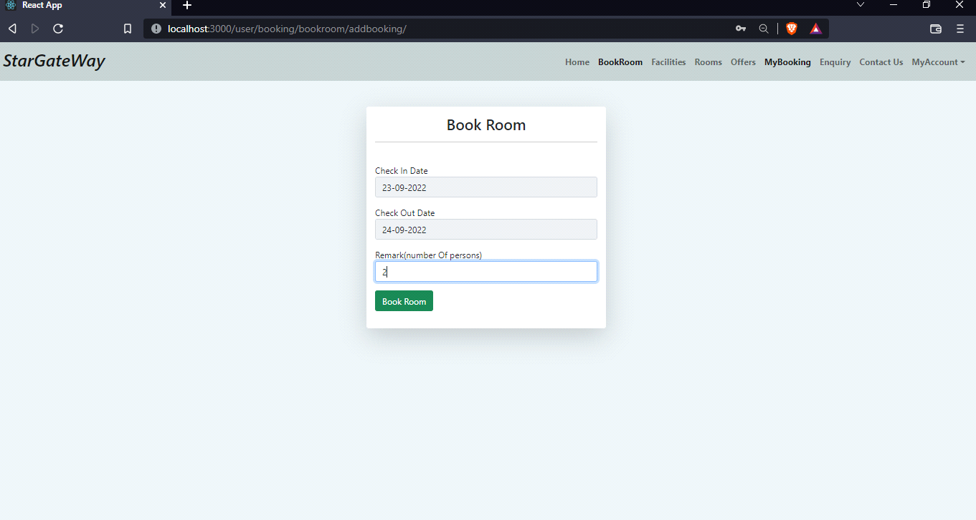

**Contact Us**

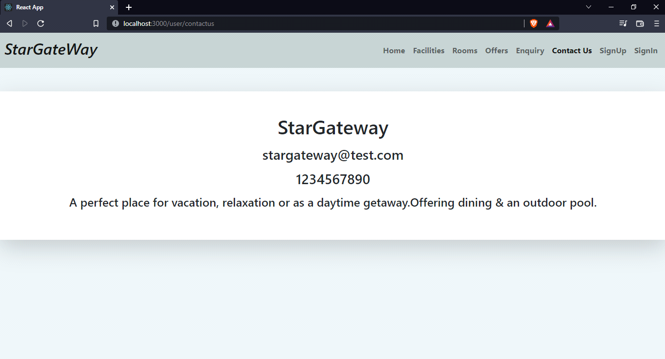

**Enquiry**

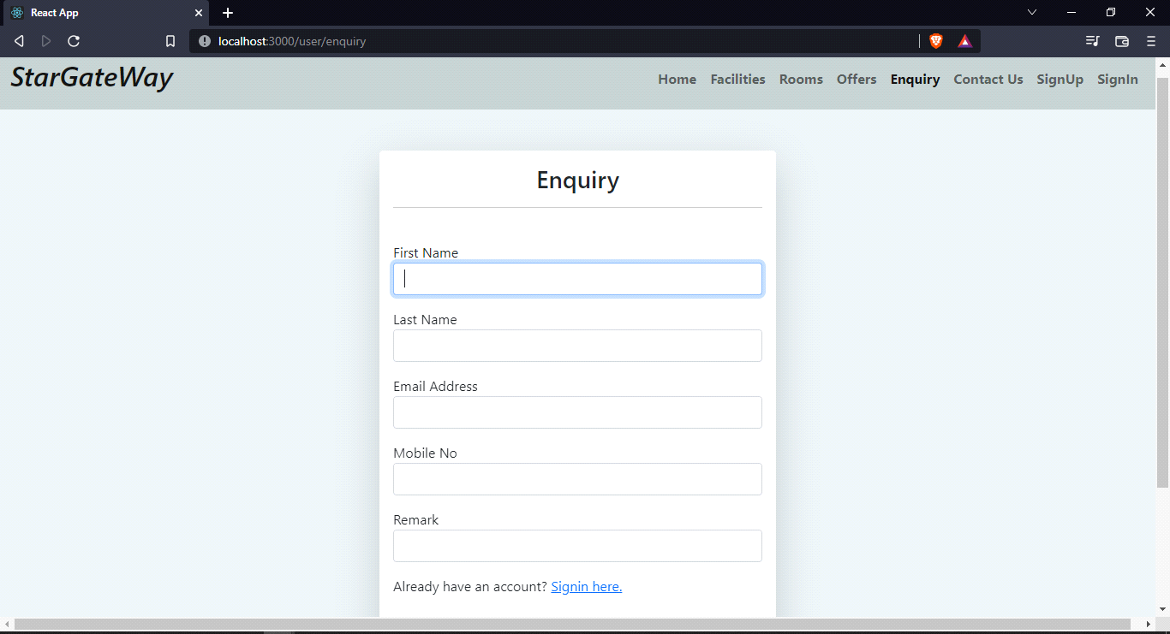

**Admin Home**

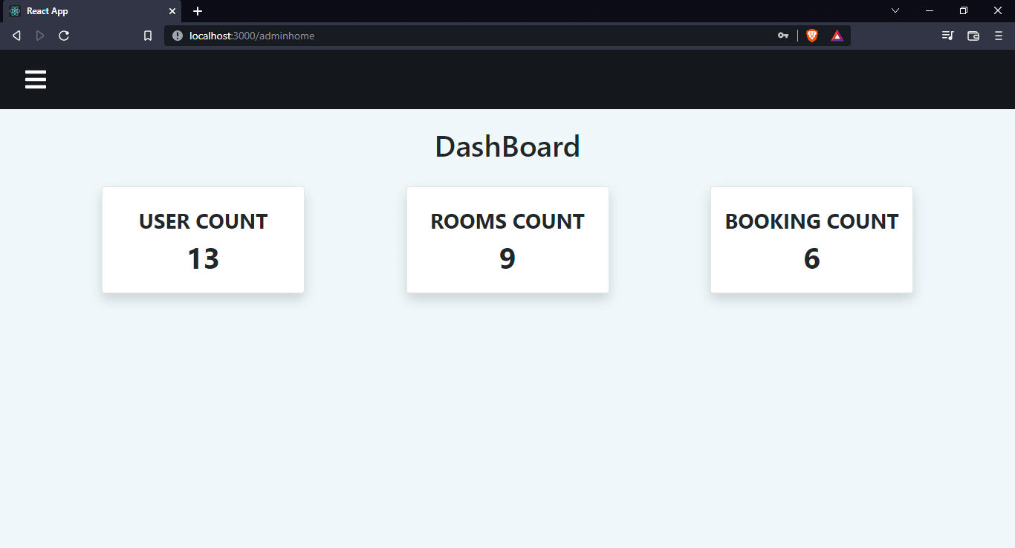

**Add Room**

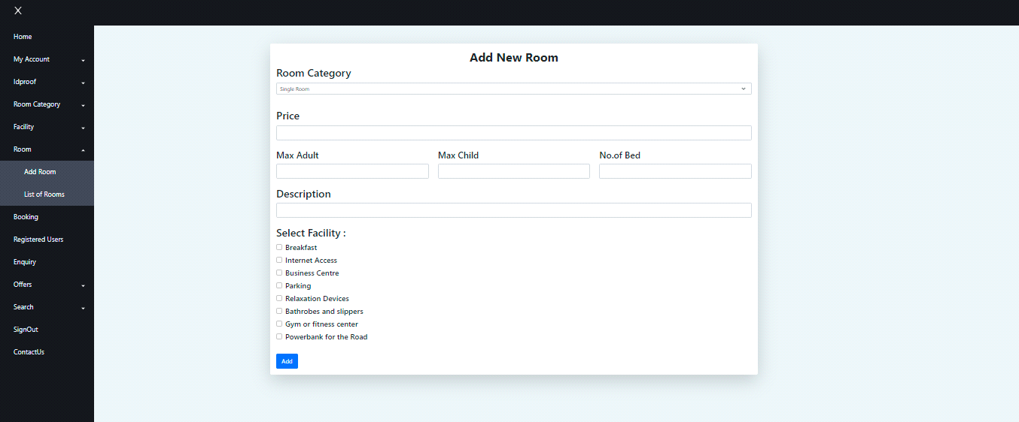

**Room List**

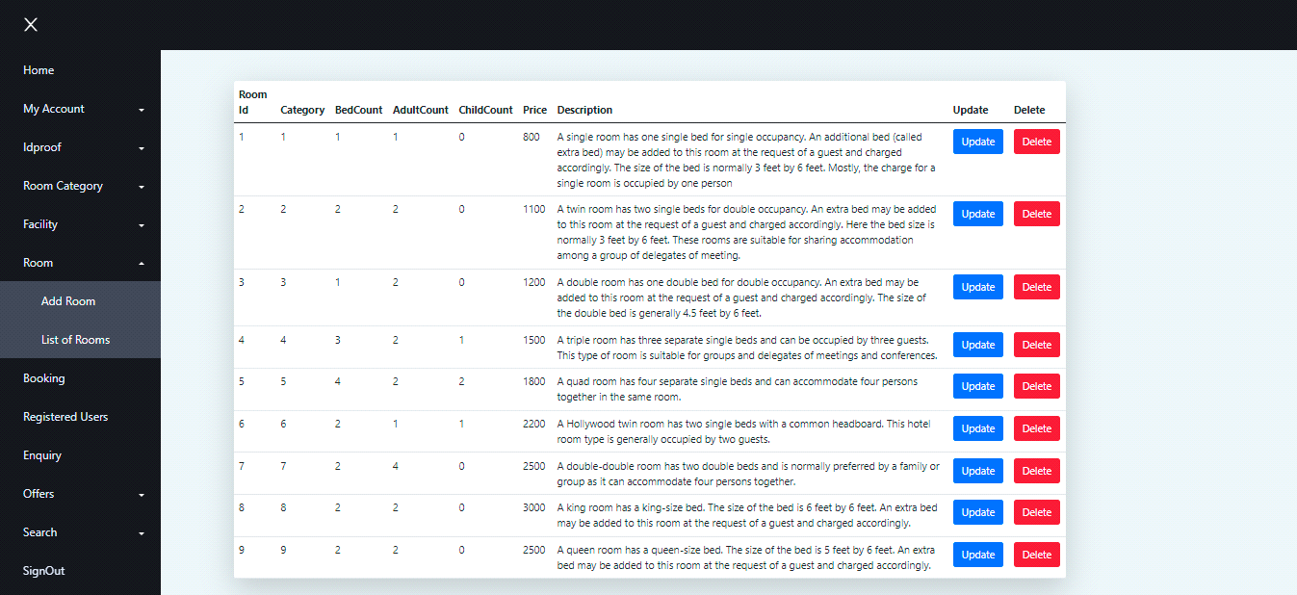

**Booking List**

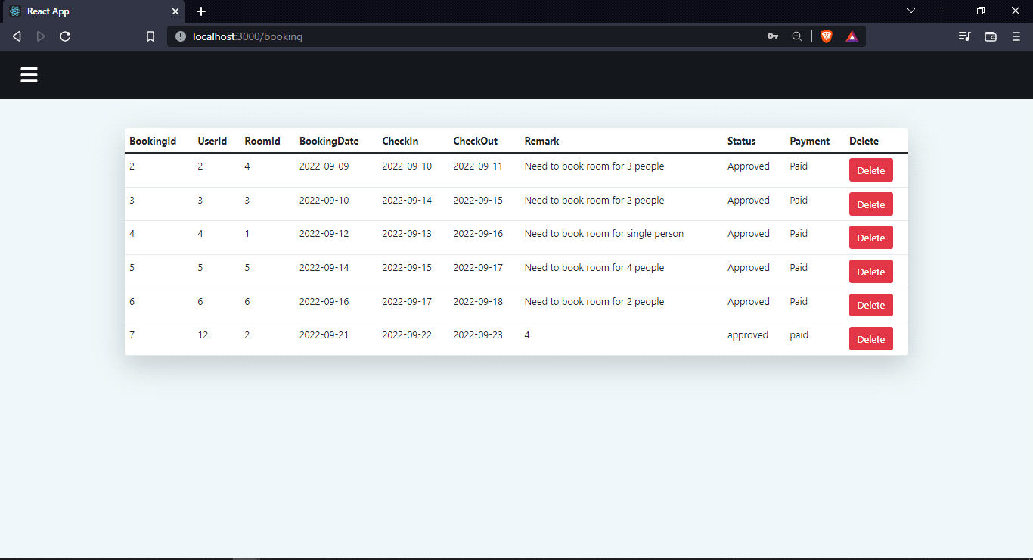

**Add Idproof**

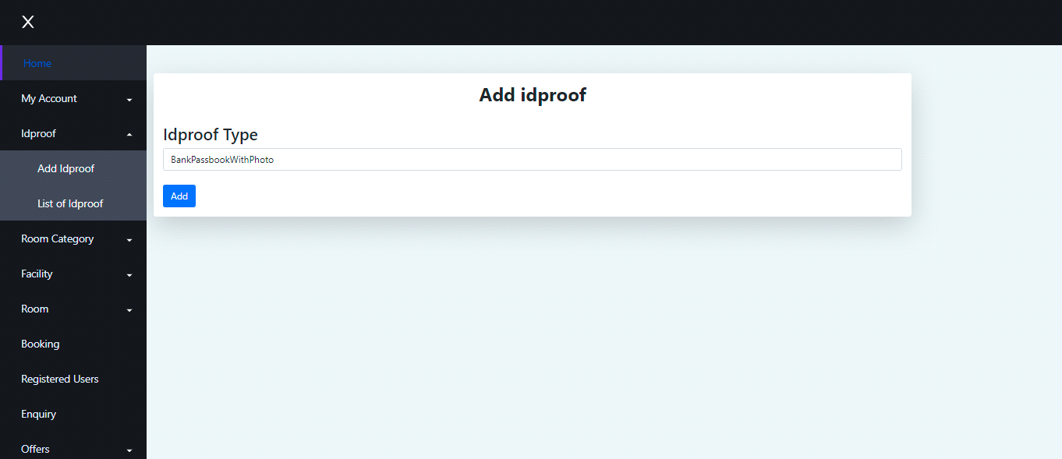

**Idproof List**

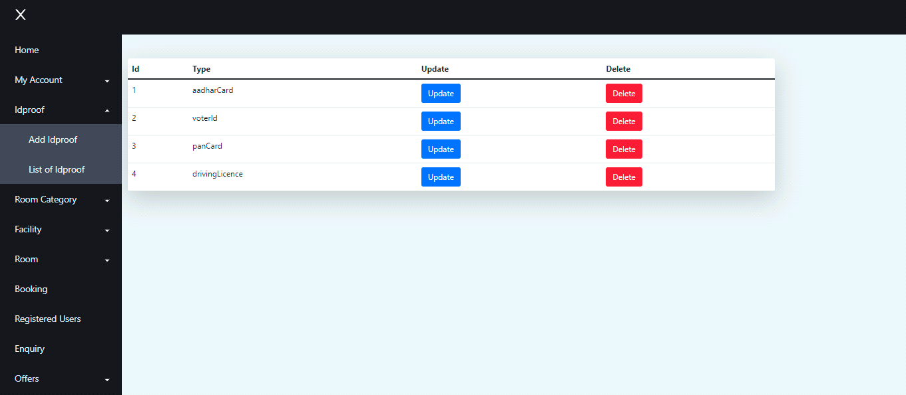

**Add Room Category**

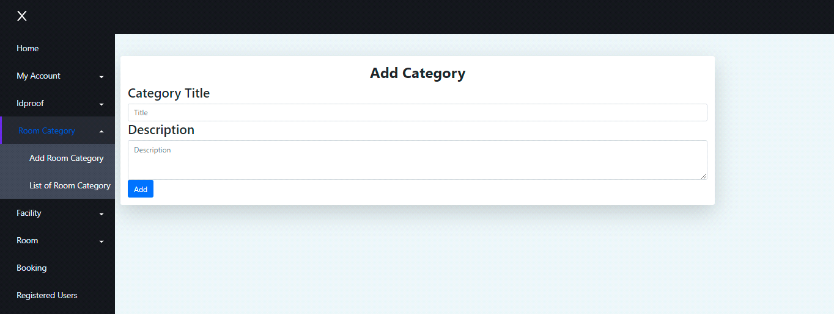

**Room Category List**

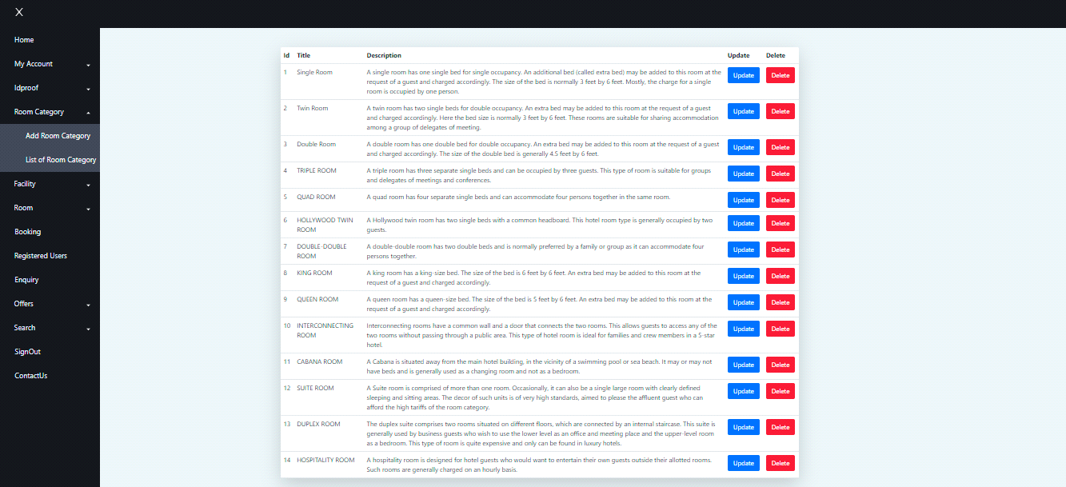

**Add Facility**

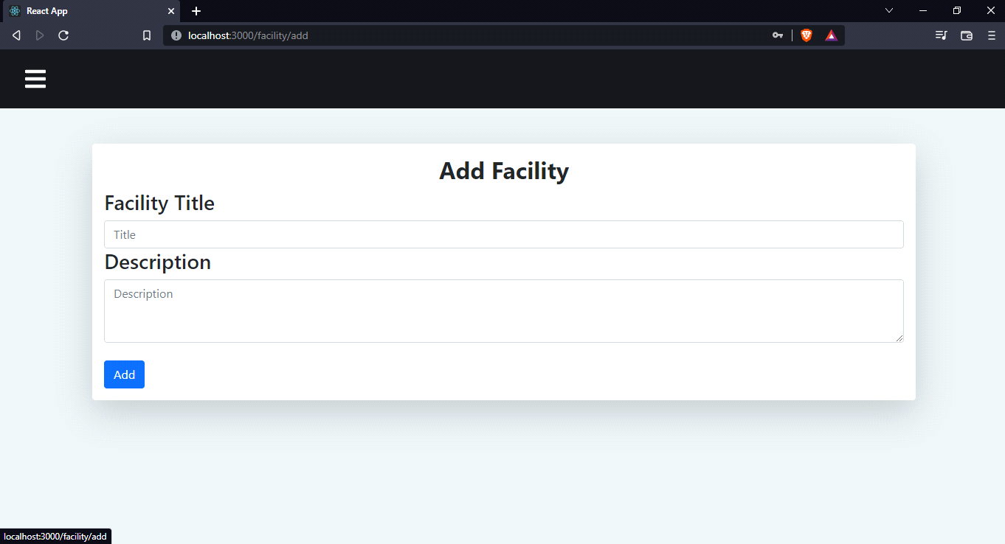

**Facility List**

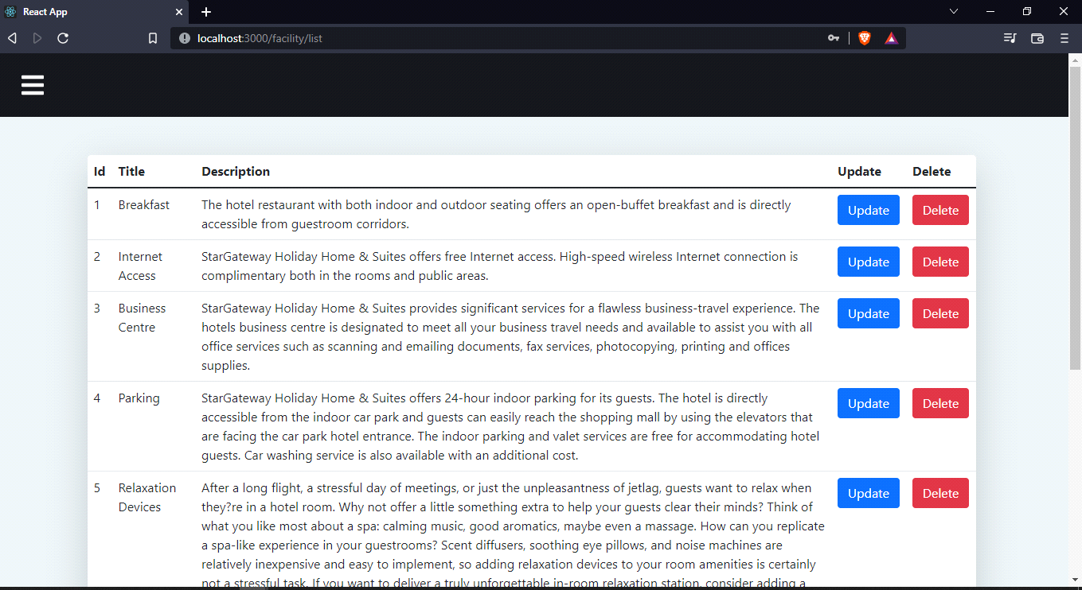

**Enquiry List**

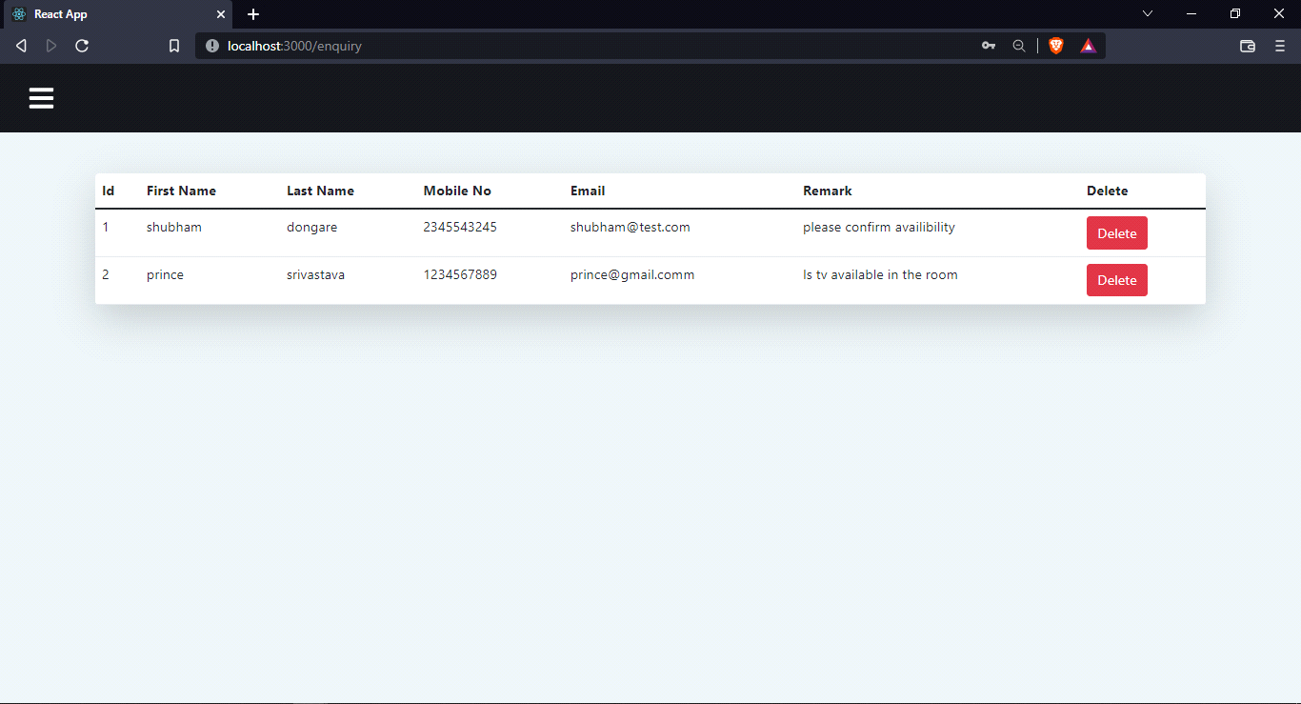

**Add Offers**

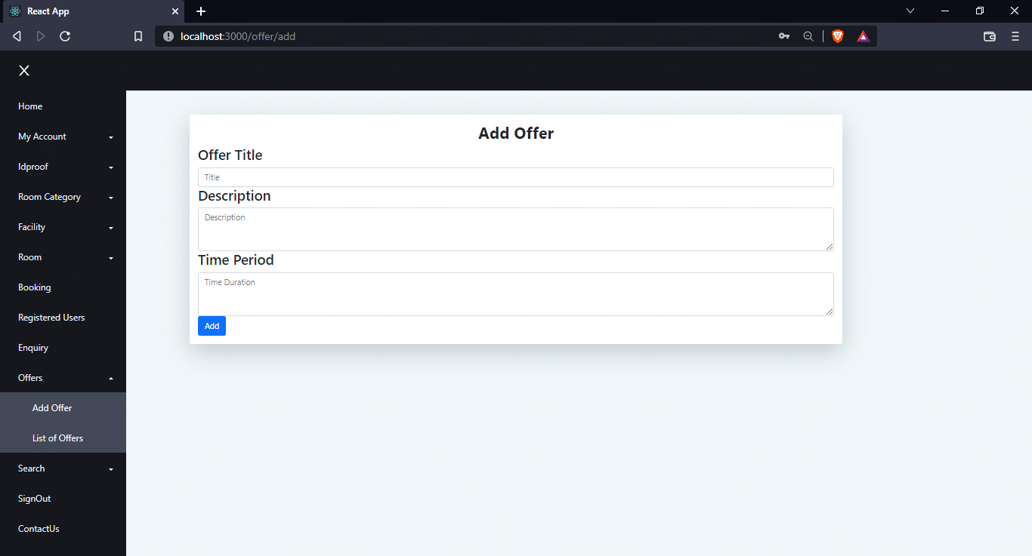

**Offers List**

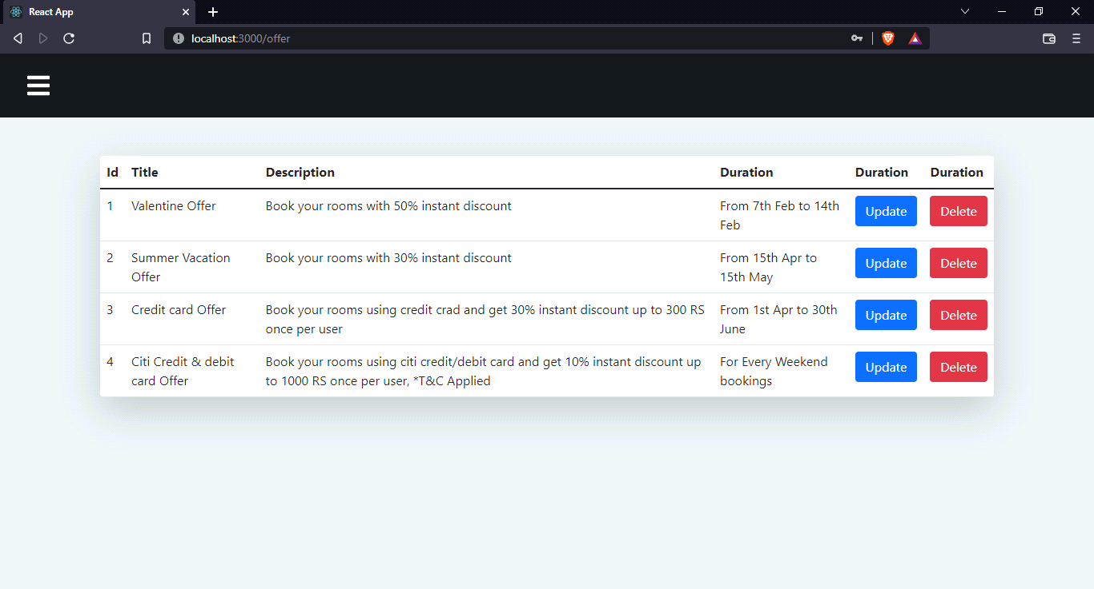

**Search By User Id**

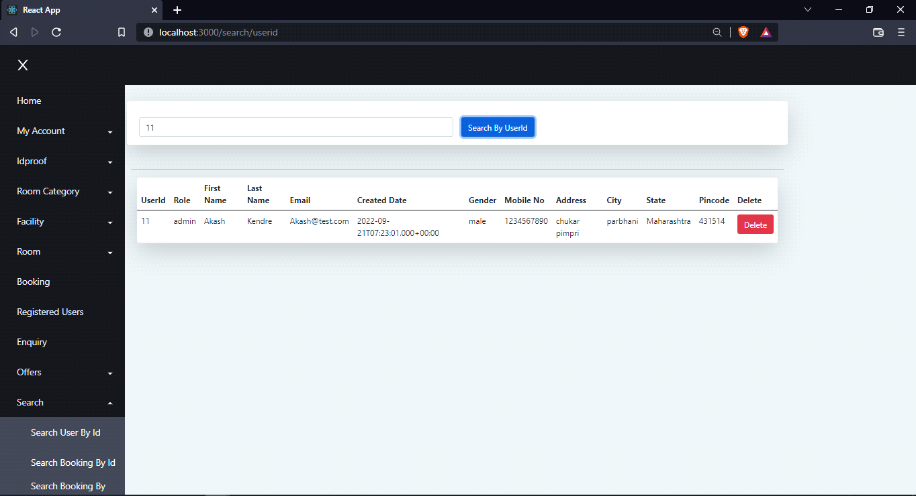

**Search By Booking Id**

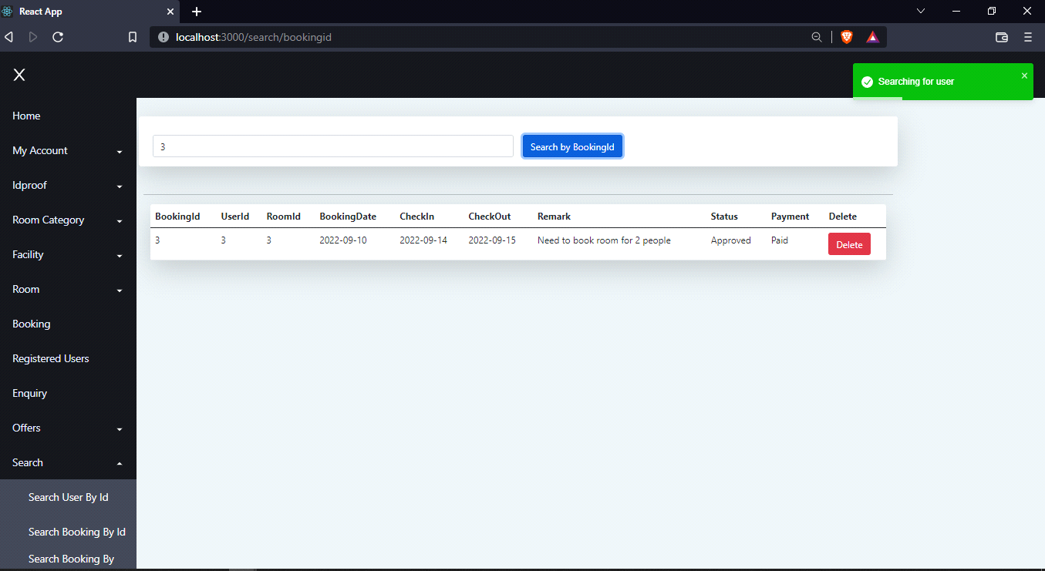

**Search By Date**

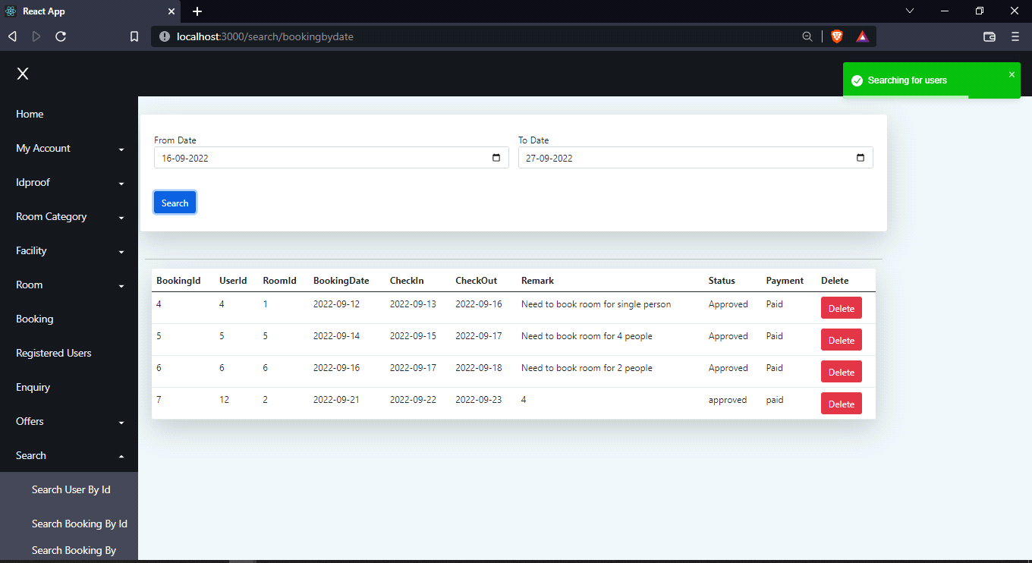

**Contact Us**

